Pharmacy Management And Control System (PMACS)

Use Case Summary Document

Version No. 0.2

Project Document Revision History
VersionNumber | Date | Revision Author | Description of Revision
0.1 | 2/28/2017 | Erik Johnson | Initial draft of document
0.2 | 3/24/2017 | Erik Johnson | All use case specifications complete

Table of Contents
1. Introduction 4
2. Project/Application Actors 4
3. Use Case List 5
4. Use Case Diagram(s) 6
4.1 Use Case Diagram 1 (High-Level) 6
5. Use Case Summary 7
5.1 Ring Up Customer ( 7
5.2 View/Update Store Information/Close Store 7
5.3 Sales Report Creation 7
5.4 Update Sales Promotions and Related Items 8
5.5 Manage Inventory 8
6. Use Case Summary Review and Signoff 9

Introduction
This document captures BUSINESS requirements at a high level by identifying ALL the use cases in a project/application.
Write a few paragraphs describing the purpose of the project/application in the Introduction.
Managing a pharmacy in and of itself is already a difficult task. A pharmacy has to be able to keep records pertaining to customer accounts, process prescriptions and their approvals, maintain sales information and portray it in such a way as to make adjustment to market supply and demand an easy task, and track inventory levels and reordering, among many other things. The labor and resource expenditure required to manage all these things in tandem and tie them together in a usable manner is no small expense for a pharmacy.
The Pharmacy Management and Control System (or PMACS), is a pharmacy management system geared specifically towards pharmacies that aims to solve these issues. PMACS is a software system that enables these pharmacies to more efficiently and robustly manage their critical faculties within an integrated system. PMACS ties together accounting, customer management, point-of-sale terminals, inventory management and sales reporting in a manner that is intuitive, reliable and easy to learn.

Project/Application Actors
An actor is someone or something (e.g. application system) outside the system or business that interacts with the application. List the actors involved in ANY use case. Actors should be a person, system, or time.
Actor Name | Description
Cashier | Individual that interacts with customers directly and enters orders into the Point of Sale (POS) system.
Corporate Employee | Corporate HQ employee that uploads parameter files for en masse item changes, company-wide sales reports, and adding and deleting stores.
Sales Manager | The individual that runs sales reports, adjusts promotional settings such as Customer Coupons and Company-wide Sales/Discounts, and manages the Related Items feature.
Store Manager | The individual that manages store information, closes out the store at the end of the day (for inventory replenishment from warehouse) and manages the threshold for the AccuStock (tm) feature.
Inventory Manager | The individual that manages item data and store assignment.
System | The entity that performs batch processing and automated tasks including but not limited to processing store creation and deletion, incoming inventory allocation, vendor reorder request generation, batch inventory item data updates, company-wide sales report generation, and automatic adjustment of AccuStock (tm) thresholds.
Vendor | Sends files containing inventory data for replenishment of warehouse stock, receives files containing warehouse replenishment orders.

Use Case List
List ALL use cases identified for the project/application.
- Ring Up Customer
- Sales Report Creation
- Update Sales Promotions and Related Items
- View/Update Store Info/Close Store
- Manage Inventory

Use Case Diagram(s)
Show diagram(s) that - ALL actors and ALL use cases identified in sections 2 and 3 must be represented somewhere in the diagram(s). IF multiple use case diagrams are created because of groupings of business functionality assign a number and name to each diagram for ease of reference.

Use Case Diagram 1 (High-Level)
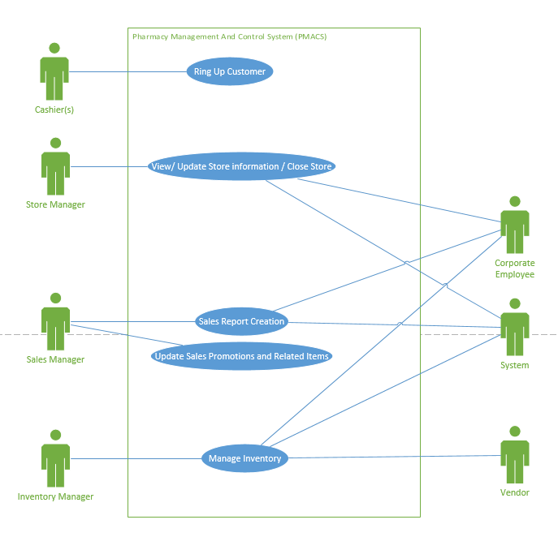

Use Case Summary
For each use case include: Introduction of use case (one paragraph, will also be “introduction” to individual use case specification document), use case diagram number and name reference (if exists), list of main actors and list of secondary actors (these MUST match the lists in the individual use case specification document).

Ring Up Customer (
5.1.1 Introduction
This use case handles the interaction between a store cashier, the system, and an additional store employee. This use case is called when a transaction is in process with a customer. It will also be used to produce prescription labels, and create and modify customer accounts. The system will create identification numbers for new accounts and notify the cashier if a customer is eligible for a refill based on the information in their account. The additional employee must approve prescription refills when they are requested.
5.1.2 Main Actors
Cashier
5.1.3 Secondary Actors
Other Employee

View/Update Store Information/Close Store
5.2.1 Introduction
The purpose of this use case is the interacting between a Store Manager and the company’s inventory system. The store manager will be able to use the inventory system to request additional inventory of specific items if they deem it necessary. The system will also have the capability to automatically order additional inventory if a specific item is shown to frequently be out of stock. It will also be able to reduce the amount ordered of a specific item if that item is frequently in stock. The system will also produce a report that will state if one of the two previous changes were made in the overnight process.
5.2.2 Main Actors
Store Manager
5.2.3 Secondary Actors
System

Sales Report Creation
5.3.1 Introduction
Sales Managers need a way to summarize and present historical sales information based on information as recent as possible. The information needs to be presented in a report, and categorized by either store (listing all item sales for that particular store) or item (listing sales of a particular item across stores). The report should be able provide information for specific time periods, initially given as daily, weekly, monthly and yearly. If a yearly report is requested for a previous year, the report should be labeled for Jan. 31 - Dec 31 of that year. If for the current year, a year to date should be calculated the report should be labeled as such.
Additionally, as part of the Sales Reports functionality, PMACS, running an automated offline batch process, will need to create Sales Reports based on a parameter file received during the day. The reports will list all stores as well as grand totals for the entire company and will be specified by the parameter filer to use a weekly, monthly or yearly period.
5.3.2 Main Actors
Sales Manager
5.3.3 Secondary Actors
System
Corporate Employee

Update Sales Promotions and Related Items
5.4.1 Introduction
The purpose of this use case will be to describe the functional and non-functional business requirements that occur when updating sales promotions and related items. User should be able to create and delete coupons that will provide discounts across whole orders, apply and remove Item Discounts on specific items, and update Related Items.
5.4.2 Main Actors
Sales Manager
5.4.3 Secondary Actors
None

Manage Inventory
5.5.1 Introduction
This use case expresses the requirements surrounding managing the inventory. This includes displaying inventory information, as well as modifying this information. The user should be able to input an item number or name, be presented with the corresponding item’s information, and have the option to edit this information. The user should also be able to remove items from the inventory list at either a store or a company level.
5.5.2 Main Actors
System
Inventory Manager
5.5.3 SecondaryActors
Vendor

Use Case Summary Review and Signoff
Review and Signoff of the Use Case Summary
Name | Project Team Role | Signature | Date
Erik Johnson | Team Lead | EJ | 3/1/2017

